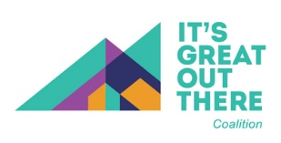

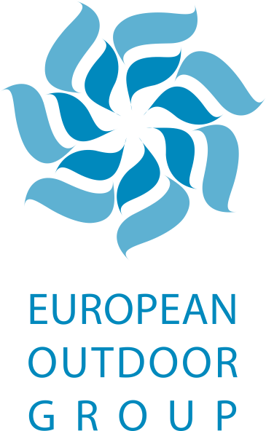
New research reveals greater public appetite for outdoor activities after COVID
News Release
For immediate release
08/06/2020

New research released today reveals that the appeal of outdoor activities has been boosted by enforced COVID-19 restrictions. In a survey of consumers in seven countries* – UK, France, Germany, Spain, Italy, Poland, Sweden – 70% of respondents stated that they are specifically looking forward to participating in outdoor activities after lockdown eases. In addition, 67% agreed that they have really missed being able to take part in pursuits such as hiking, climbing, cycling, snow sports and other mountain activities during lockdown, while 86% stated that outdoor activities are essential for people’s wellbeing. Across Europe, 58% of consumers said that they have missed outdoor activities above all else while restrictions have been in place.

The research was undertaken during late April and early May on behalf of the European Outdoor Group (EOG) and the It’s Great Out There Coalition by consumer trends specialist Foresight Factory, with 1,000 active consumers in each market completing the study. The outdoor sector in the seven countries that took part is worth €3.9bn at wholesale. The wide-ranging survey explored participation levels in different outdoor activities in detail and identified variations by country, age, gender and other demographic measures. The research also explored the barriers that prevent people getting active in the outdoors and identified opportunities for overcoming those.

Of those who completed the survey, 62% usually participate in outdoor activities about monthly or more often, while 29% do so a few times a year. The high level of respondents who are looking forward to doing more in the outdoors after restrictions ease provides a significant sign of optimism for the European outdoor sector and supports the European Outdoor Group’s recent open letter to authorities to do more to promote participation and provide guidance for the safe reopening of outdoor activities.

A series of questions about the impact of COVID-19 clearly revealed an increased appreciation of the outdoors as a result of the pandemic. Over 50% of respondents have had reduced physical activities outdoors during the outbreak and 58% have missed those above all else during confinement, rising to 72% in Spain and 65% in Italy, two countries which imposed some of the most restrictive lockdowns. 70% of respondents are now looking forward to participating in more outdoor activities as a priority when restrictions end. The impact of different lockdown strategies is clear. In Sweden, which did not impose mass confinement, there is not the same strength of feeling around missing outdoor activities or looking forward to resuming them.

Mark Held, EOG president, comments: “This is a comprehensive and robust piece of research in seven of the biggest outdoor markets in Europe, and the results are very clear. Wherever citizens have experienced significant restrictions, they have really missed the ability to access the outdoors. More than that, confinement has given active consumers a greater appreciation of the nature that they have been missing.

“The outdoor sector is absolutely ready to welcome everyone, from novice climbers to first-time hikers, but authorities across Europe also need to act and respond positively to this growing appetite. It is essential that the public is encouraged to participate in outdoor activities safely and responsibly with the right information from experts. The European Outdoor Group and It’s Great Out There Coalition will continue to campaign and support all such efforts, and we will work with all of our members and partners to help citizens everywhere as they get more active outdoors.”

The research results will be used to support the next stage of the pan-European #itsgreatoutthere campaign. The project is led by the It’s Great Out There Coalition, which was founded by the EOG to promote participation in outdoor activities across Europe. The coalition has a membership that includes some of Europe’s largest outdoor companies, who work together to inspire more people to get active outdoors. The #itsgreatoutthere team also collaborates closely with organisations such as the European Network of Outdoor Sports, the European Commission’s #BeActive project and other partners, to promote and facilitate outdoor participation.

The EOG and It’s Great Out There Coalition will work with key stakeholders throughout Europe over the coming months and use the insights from the research, to enhance the promotion of outdoor participation and maximise the impact of all activity to encourage citizens to head into nature in a safe and responsible way.

To find out more about the EOG, visit www.europeanoutdoorgroup.com, or email info@europeanoutdoorgroup.com. To find out more about the #itsgreatoutthere campaign, visit www.itsgreatoutthere.com and for more information about the It’s Great Out There Coalition, email info@itsgreatoutthere.com.

ends

For additional media information please contact Chris Lines on +44 (0)7971 868329, chris@rightlines.info or www.twitter.com/chrisjlines.

*Research methodology. Citizens were invited to take part in an online survey in seven European countries. A total of 1,000 interviews per country took place. Consumers were aged 16+ and quotas were set on gender and age to make the responses nationally representative. Other key demographics were also collected such as income, family structure and place of dwelling. All consumers had to have a minimum level of activity - those who did no physical activity were screened out as they would not be able to answer the survey.

NOTE TO EDITORS
About the European Outdoor Group
The European Outdoor Group was founded in 2003 by 19 of the world’s largest outdoor companies, all of which recognised the need for a cohesive, cross border approach to representation of the outdoor sector. In a world of increasing internationalisation, legislation, environment, the media and trade are all now multinational issues. The combined strength of the EOG’s 113 members provides the group with an extremely powerful force to represent the European outdoor industry in a constructive and positive manner. Visit www.europeanoutdoorgroup.com for more information.

About the It’s Great Out There Coalition
The It’s Great Out There Coalition is an International Non Profit Association (INPA), registered in Brussels, and set up and launched by the European Outdoor Group (EOG). Run by an executive team and non-executive board, the coalition is leading a pan-European consumer facing campaign to inspire more people to get active in the outdoors. The It’s Great Out There Coalition is funded by membership fees from some of the biggest outdoor businesses in Europe.

The coalition is working closely with European Commission in Brussels (with the European Outdoor Group), helping to represent the outdoor sector to policymakers and seeking to secure European funding for key community-led projects designed to inspire more European citizens to get active. Businesses and other organisations that operate in the outdoor sector are encouraged to join the coalition as members or supporters. For more information about terms and costs, contact info@itsgreatoutthere.com. To find out more about the It’s Great Out There Coalition and #itsgreatoutthere campaign, visit www.itsgreatoutthere.com.

About Foresight Factory
Foresight Factory is a leading data-led consumer trends agency. It helps global brands in over 60 countries reveal different, better answers for their business through the power of consumer trends and data. Foresight Factory helps its clients to see the future, grow sustainably, survive to thrive, target and spend optimally. At the heart of its trend tracking is a proprietary, global research programme which speaks to at least 30,000 consumers across 27 markets each year.
